Subnetting and route tables:

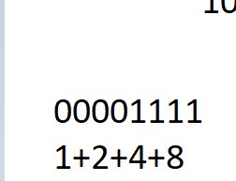

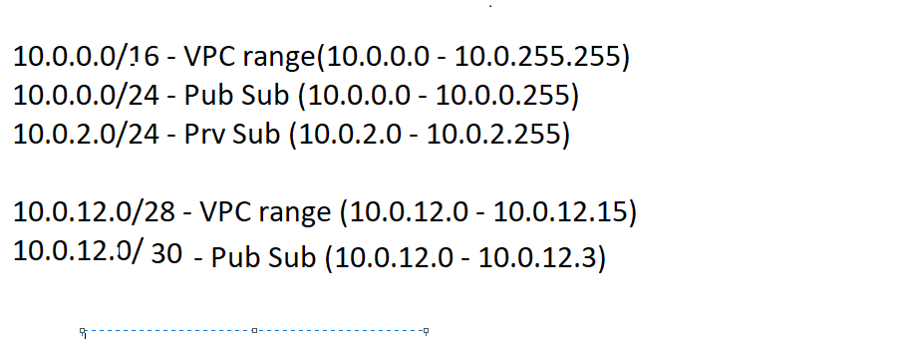

Here in second vpc we are not left with Ips for private subnets so should see for subnetting properly  
  
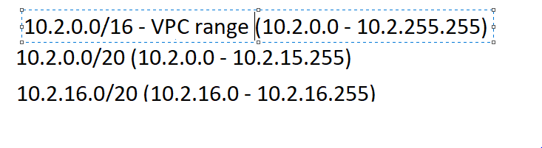  
this works properly

Have created one vpc cidr  
under vpc have created 2 subnets (public private)  
have attached an igw with one of the subnets and then that becomes public subnet which could contact the internet for all those services who are in public subnets,  
for public subnet resources to connect with private ones, need to add the ip address of public subnet instance in the sg inbound rules of instance which is in private subnet as source.  
  
VPC Configuration:  
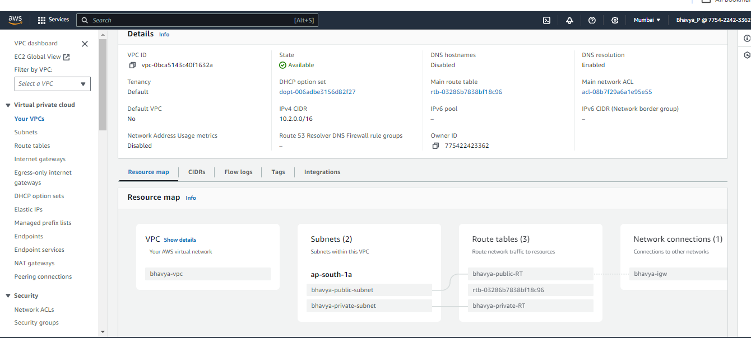  
  
bhavya’s private subnet  
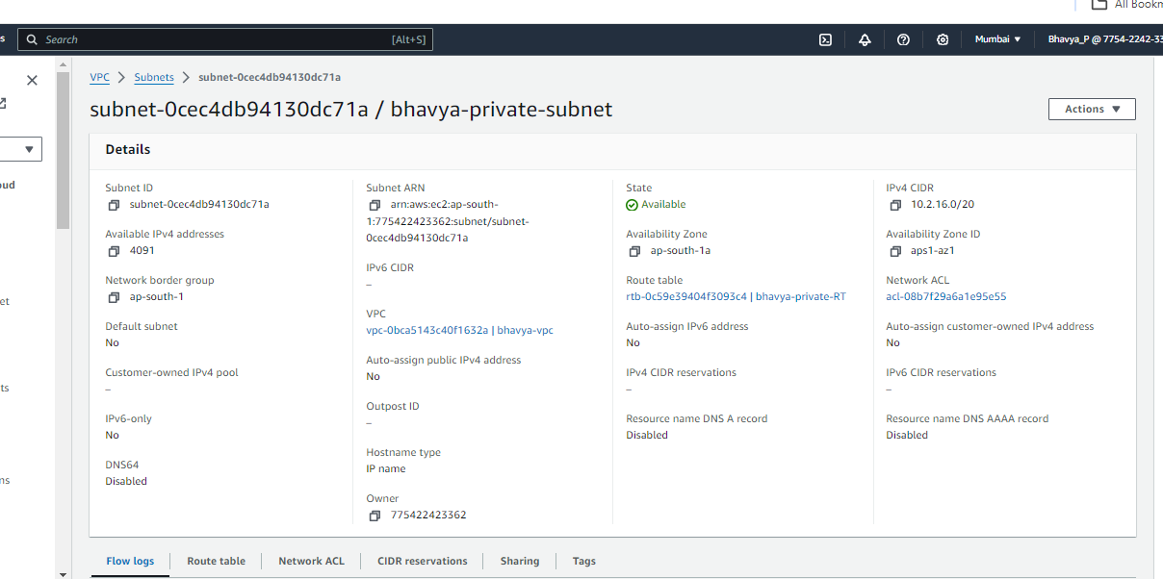  
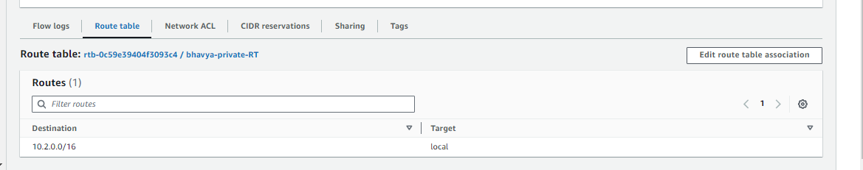  
public subnet

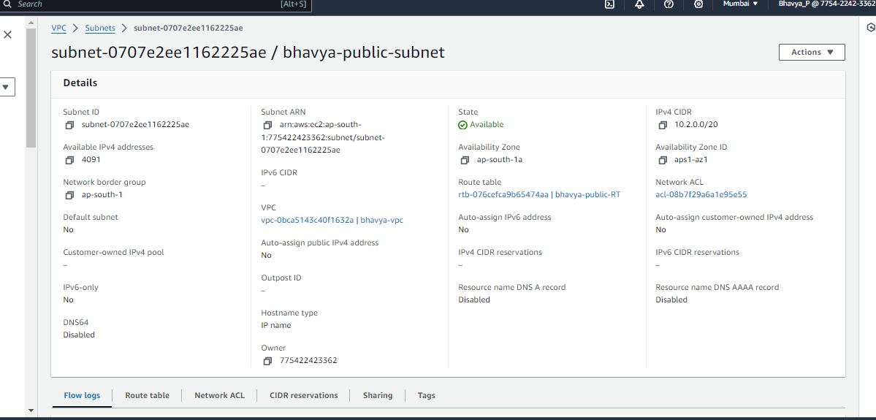  
  
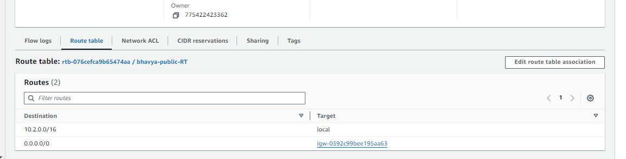  
  
after creating subnets, attach IGW to public subnet  
  
Attach IGW from your VPC  
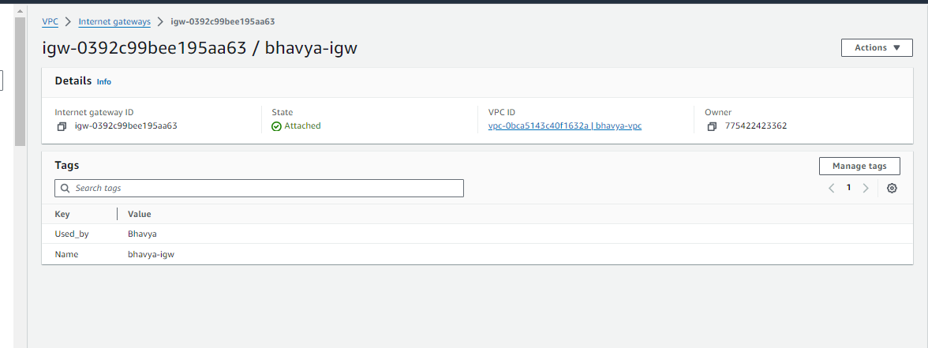  
  
private RT  
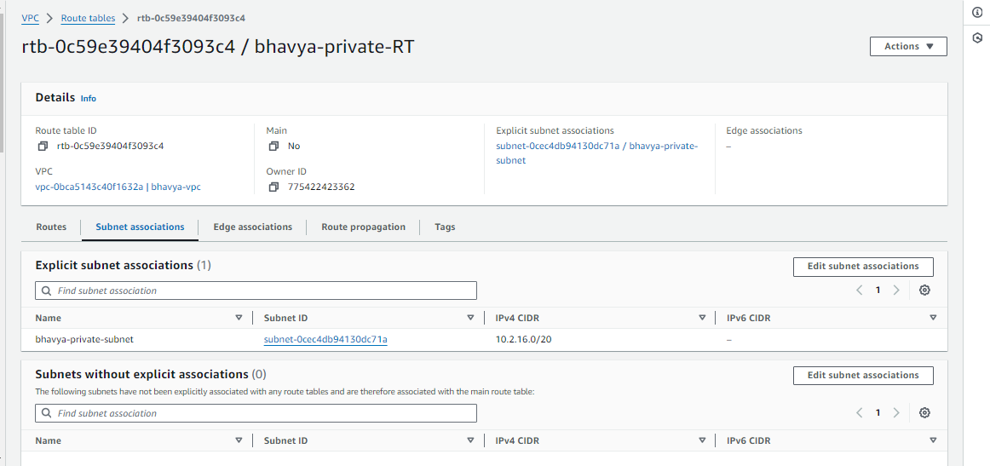  
ROUTES  
Attaching Routes to public RT  
  
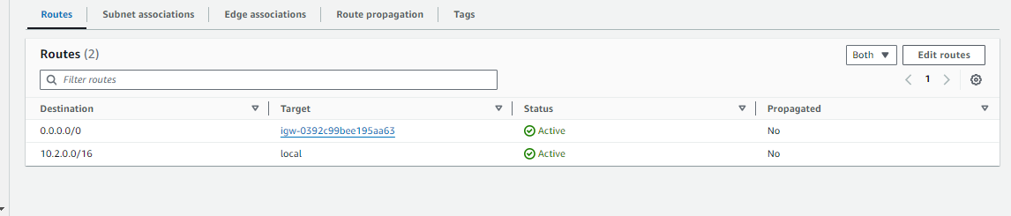

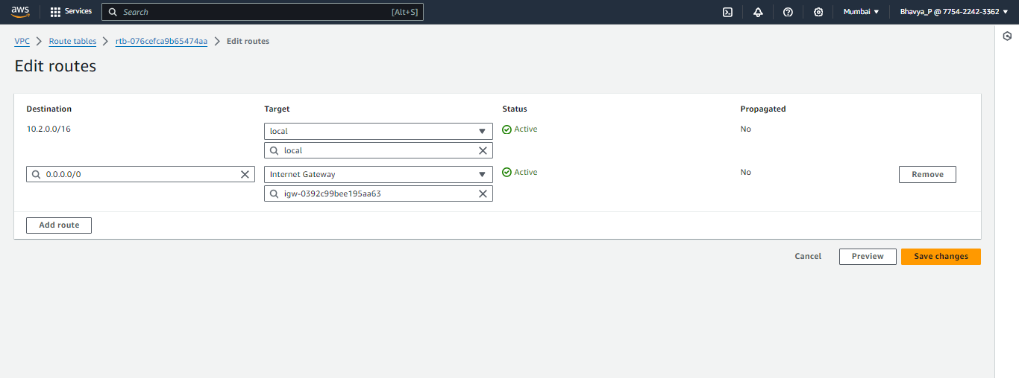  
after this if you launch your ec2 established in public subnet this would connect to internet, if you have updated the sg for private instance and allowed incoming traffic from public subnet, then private instance would also connect to internet.